TECHNICAL REPORT – COMPUTER AND NETWORK FORENSICS:

**OVERVIEW / CASE SUMMARY**

Lardland doughnuts, a company in Springfield, believe that one of their employees, Ms Penelope Olsen is a secret agent working for their competitor Dunkin’Donuts. Penelope’s computer sent instant messaging packets over the wireless network to an unexpected computer found on the company’s wireless network. Subsequent checks on Ms Penelope Olsen reveal that her name is an alias, that she is Mrs Mona Simpson, a wanted woman, and that her last known residence was at 742 Evergreen Terrace with her son Mr H.J. Simpson. A USB stick and a mobile phone were discovered during the police search at 742 Evergreen Terrace.

**OBJECTIVES**

* Is there anyone else implicated? If so, who?
* Where was Penelope planning to travel to?
* Find the secret recipe(s).

**ANALYSIS**

***USB ANALYSIS –***

**OBJECTIVE 1**:

Ms Penelope Olsen is an alias, and her real identity is Mrs Mona Simpson, a wanted woman. Security staff monitored her laptop and her network for quite a while and found nothing suspicious. One day, there was unusual traffic in the wireless network. Some packets have been sent from Penelope’s laptop to the unidentified laptop. The objective here is to perform a forensic analysis of the image from the USB device that is retrieved by the police from the last known address.

* Is there anyone else implicated? If so, who?

There was no conclusive evidence that Penelope was leaking the secret information of the company to the competitors but on analysing the USB image we can find some interesting information.

* In the autopsy on opening the USB image we can see some data on the left side of the application.
* As we are searching for the people involved and we don’t know anyone as of now, we are going to look at some of the basic keywords like mom, dad, son, daughter, etc.
* To filter these, we use the keyword search option on the top right corner of the application.
* On typing MOM in the keyword search we can find some files popping up and we can see a doc file in which FRODO (we don’t know who it is right now) has written it to his mom.
* His mom is not Penelope as we know that his name is H.J. Simpson.

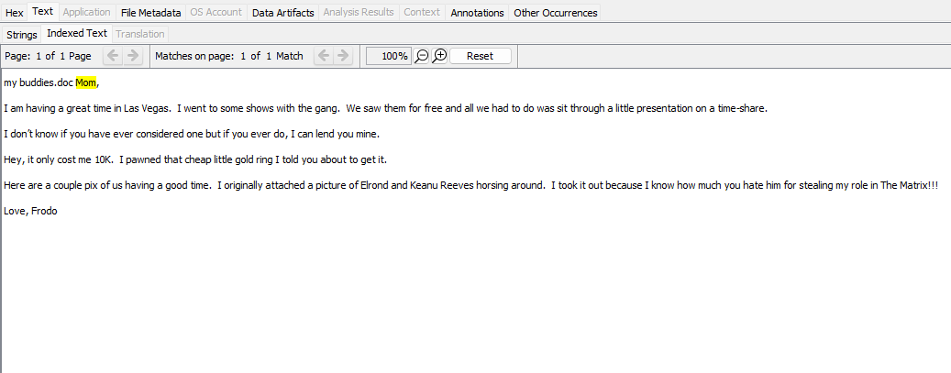

Figure : SHOWS THE MESSAGE FRODO HAS WRITTEN TO HIS MOM.

* But if we look at it carefully, we don’t find enough evidence in it and eventually we use the next keyword ‘dad’.
* Now, after using this filter we find something interesting here. There is a file ‘dad.xls’ in which there is evidence and takes us a step closer to finding out who is involved in it apart from Penelope.

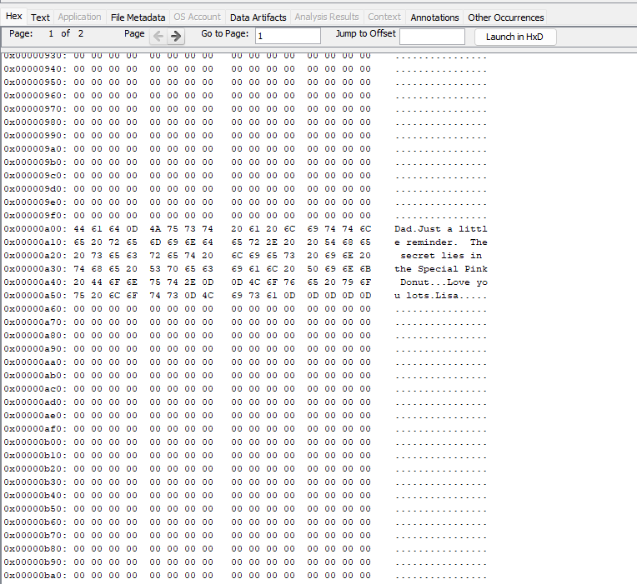

Figure : SHOWS US THE MESSAGE HIDDEN IN THE DAD.XLS FILE

* In figure2, we can see that LISA has a message written in the DAD.XLS file and hid it. In the hex part, it says “Dad. Just a little reminder. The secret lies in the pink doughnut... love you lots. Lisa”
* By this we can conclude that both Lisa and her dad are involved along with Penelope as we can see in the image that she says, “the secret lies in the special pink doughnut”. So, the pink doughnut may contain the recipe for the honey duff doughnuts.
* We can conclude that Penelope, Lisa, and Lisa’s father are the one’s behind it.

**OBJECTIVE 2:**

Penelope's computer (192.168.1.158) transmitted Instant Messaging packets to this computer through the wireless network. Shortly later, the rogue computer vanished. Based on the packet analysis, the firm believes they have been the victims of a computer abuse attack and that the suspect is about to leave.

* Where was Penelope planning to travel to?

From the packet analysis done on the Wireshark, we can see a packet has been transferred from Penelope’s laptop to another laptop (an unidentified laptop in the wireless network of the company). If observed, we can see in clear text what packet has been sent to the receiver.

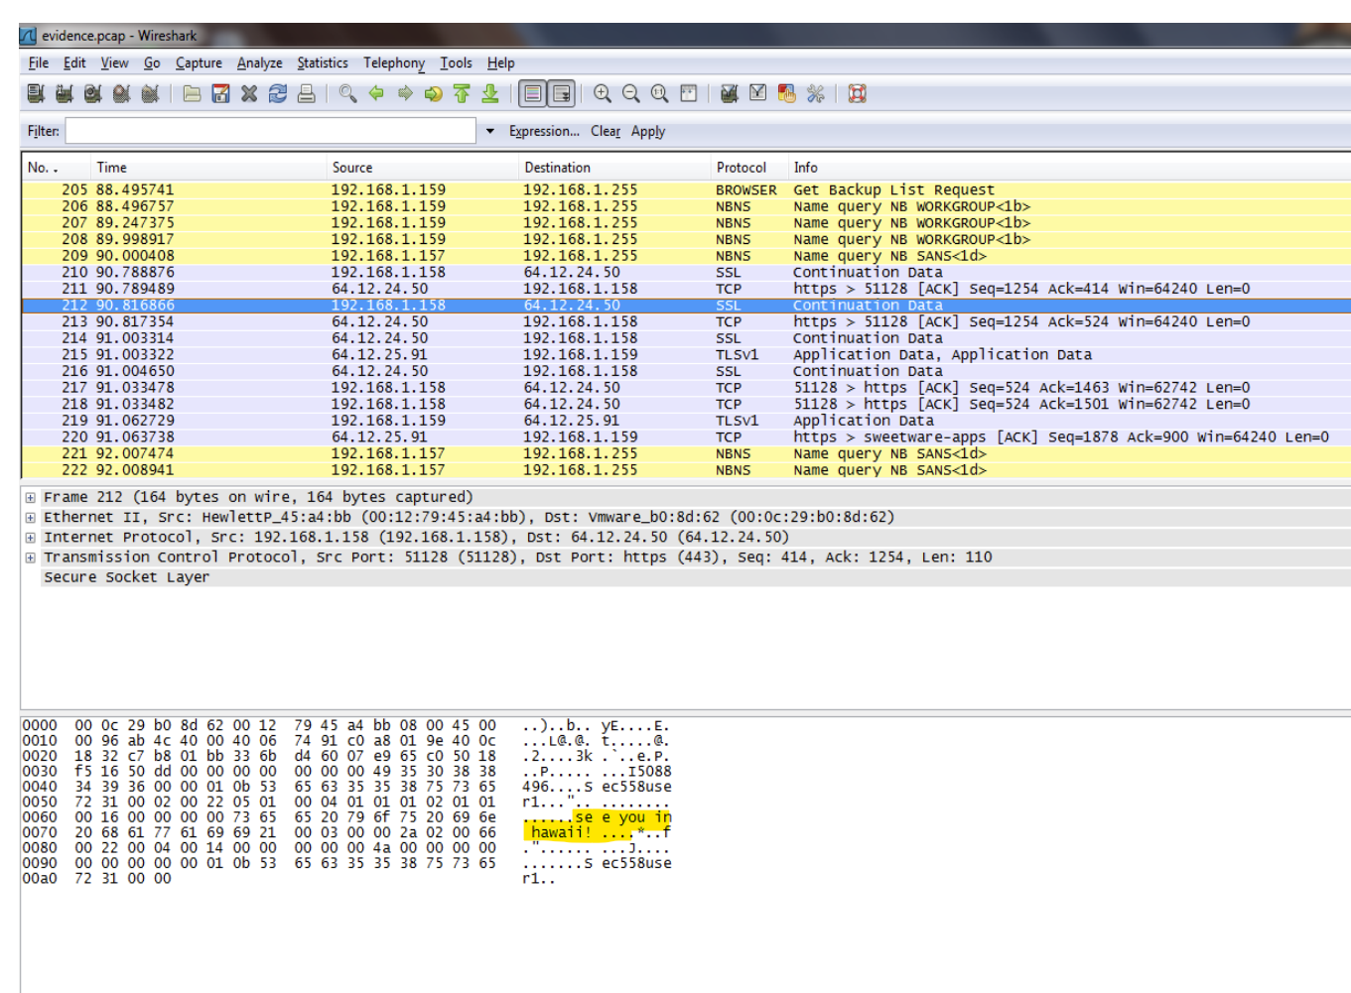

Figure : SHOWS US THE MESSAGE SENT FROM PENELOPIES LAPTOP TO THE RECEIVER LAPTOP.

Here in the interface, we can see that the message sent by Penelope’s laptop (192.168.1.158) was “see you in Hawaii!”.

So, we can conclude that Penelope was planning to travel to Hawaii.

**OBJECTIVE3:**

FINDING THE SECRET RECIPE(S):

As seen from the above pieces of evidence LISA has told to her dad that the secret lies in the pink doughnut. So, we can now assume that the recipe is hidden in either an image of the pink doughnut or a file named pink doughnut.

When we search for images of the pink doughnut, we come across several images, and we cannot conclude that the secret lies in the pink doughnut itself.

* So, we now analyse all the available images and look for some evidence.
* Most of them use steganography encoding to hide information within other non-secret text or data.
* We can assume that they have used steganography to hide the information in the images and we proceed to decode the images available.
* We can also use binwalk in Kali Linux to find out hidden files in a file.
* Images are found on the left side of the autopsy interface under a single literal keyword search.

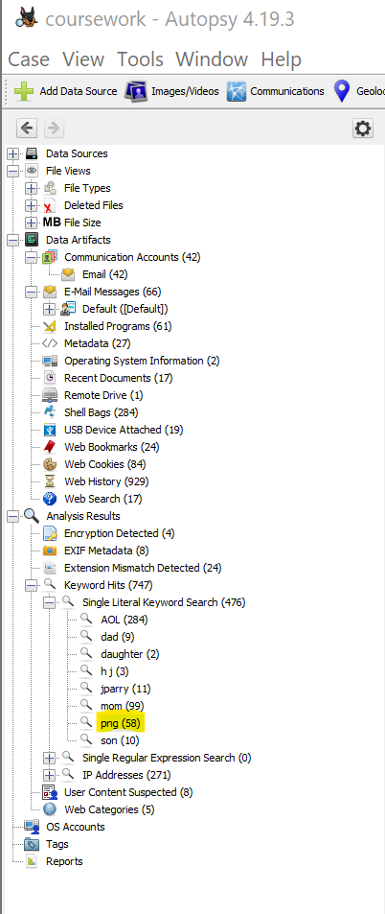

Figure : Show us where to find images.

* On clicking the png we find several images which we try decoding one by one to find some information.
* 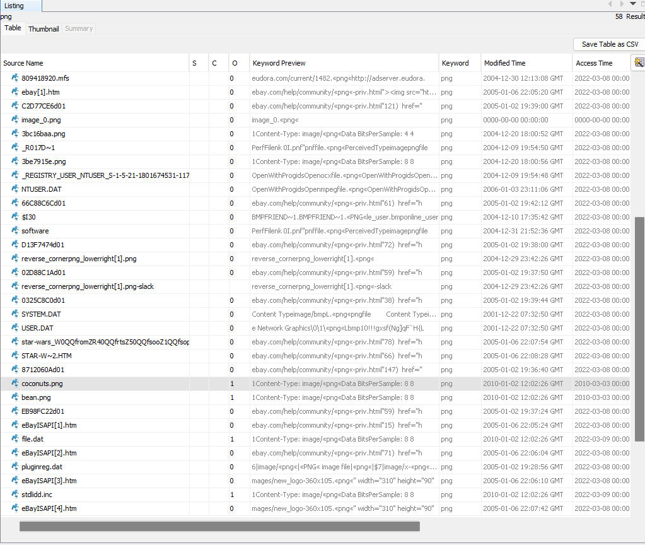

Figure : SHOWS US SEVERAL IMAGES AVAILABLE ON THE USB.

* We now start analysing the images in the png section while assuming that they have used steganographic encoding to hide the information.

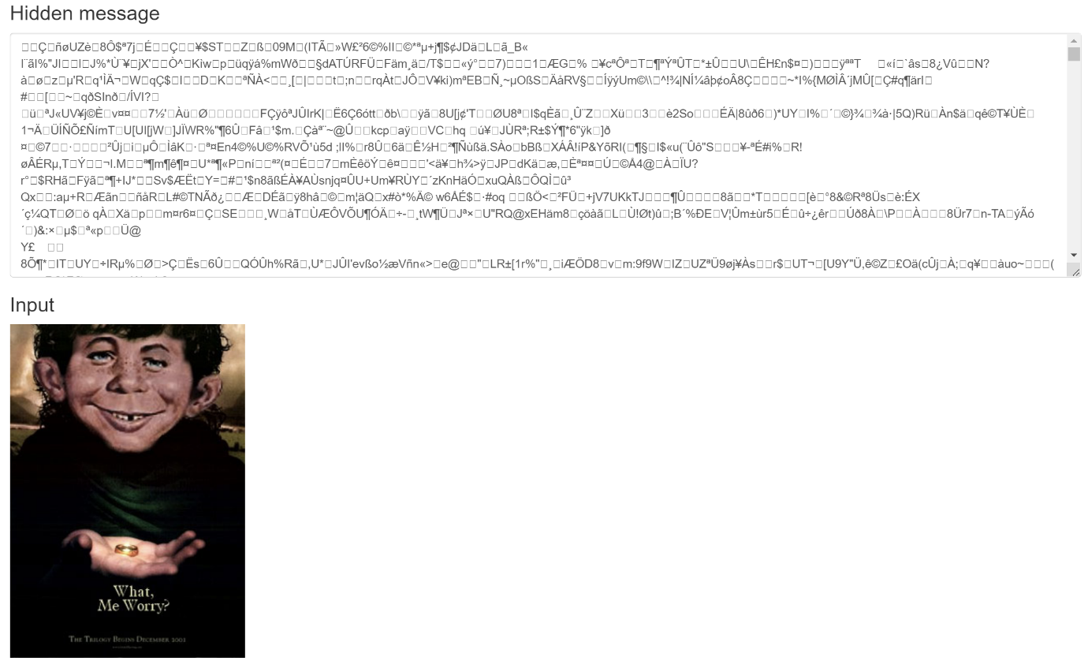

Figure : ATTEMPT TO DECODE ONE OF THE IMAGES.

* In the above figure, we can see that there is not much information revealed, it is a failed attempt, and we move on to decode more images.
* After a few more attempts most of the images gave a gibberish output while there was some interesting information in 3 of the images.

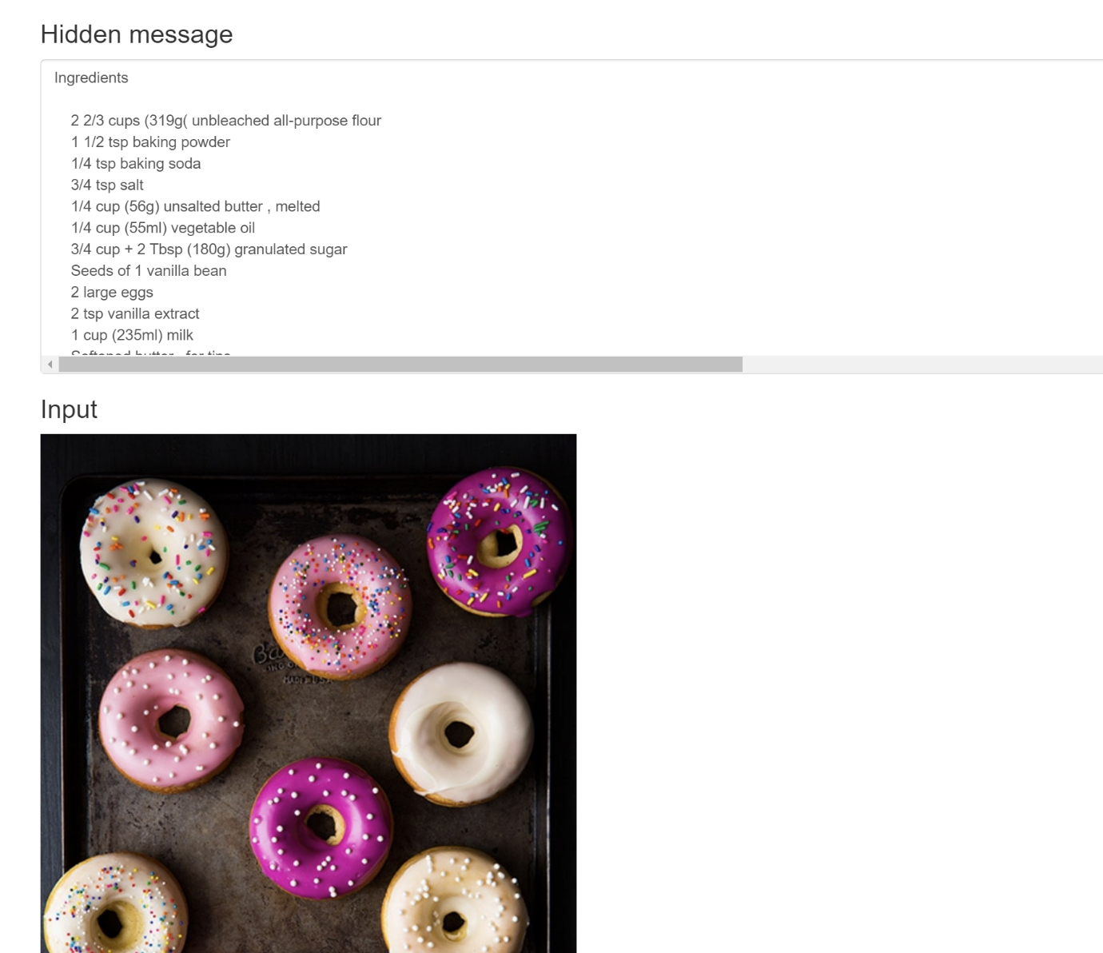

Figure : GIVES US SOME INFORMATION AS AN OUTPUT.

* In the above figure (from file bean.jpg) we can see that a recipe is hidden in the image, and we decoded it by using a steganography decoder.

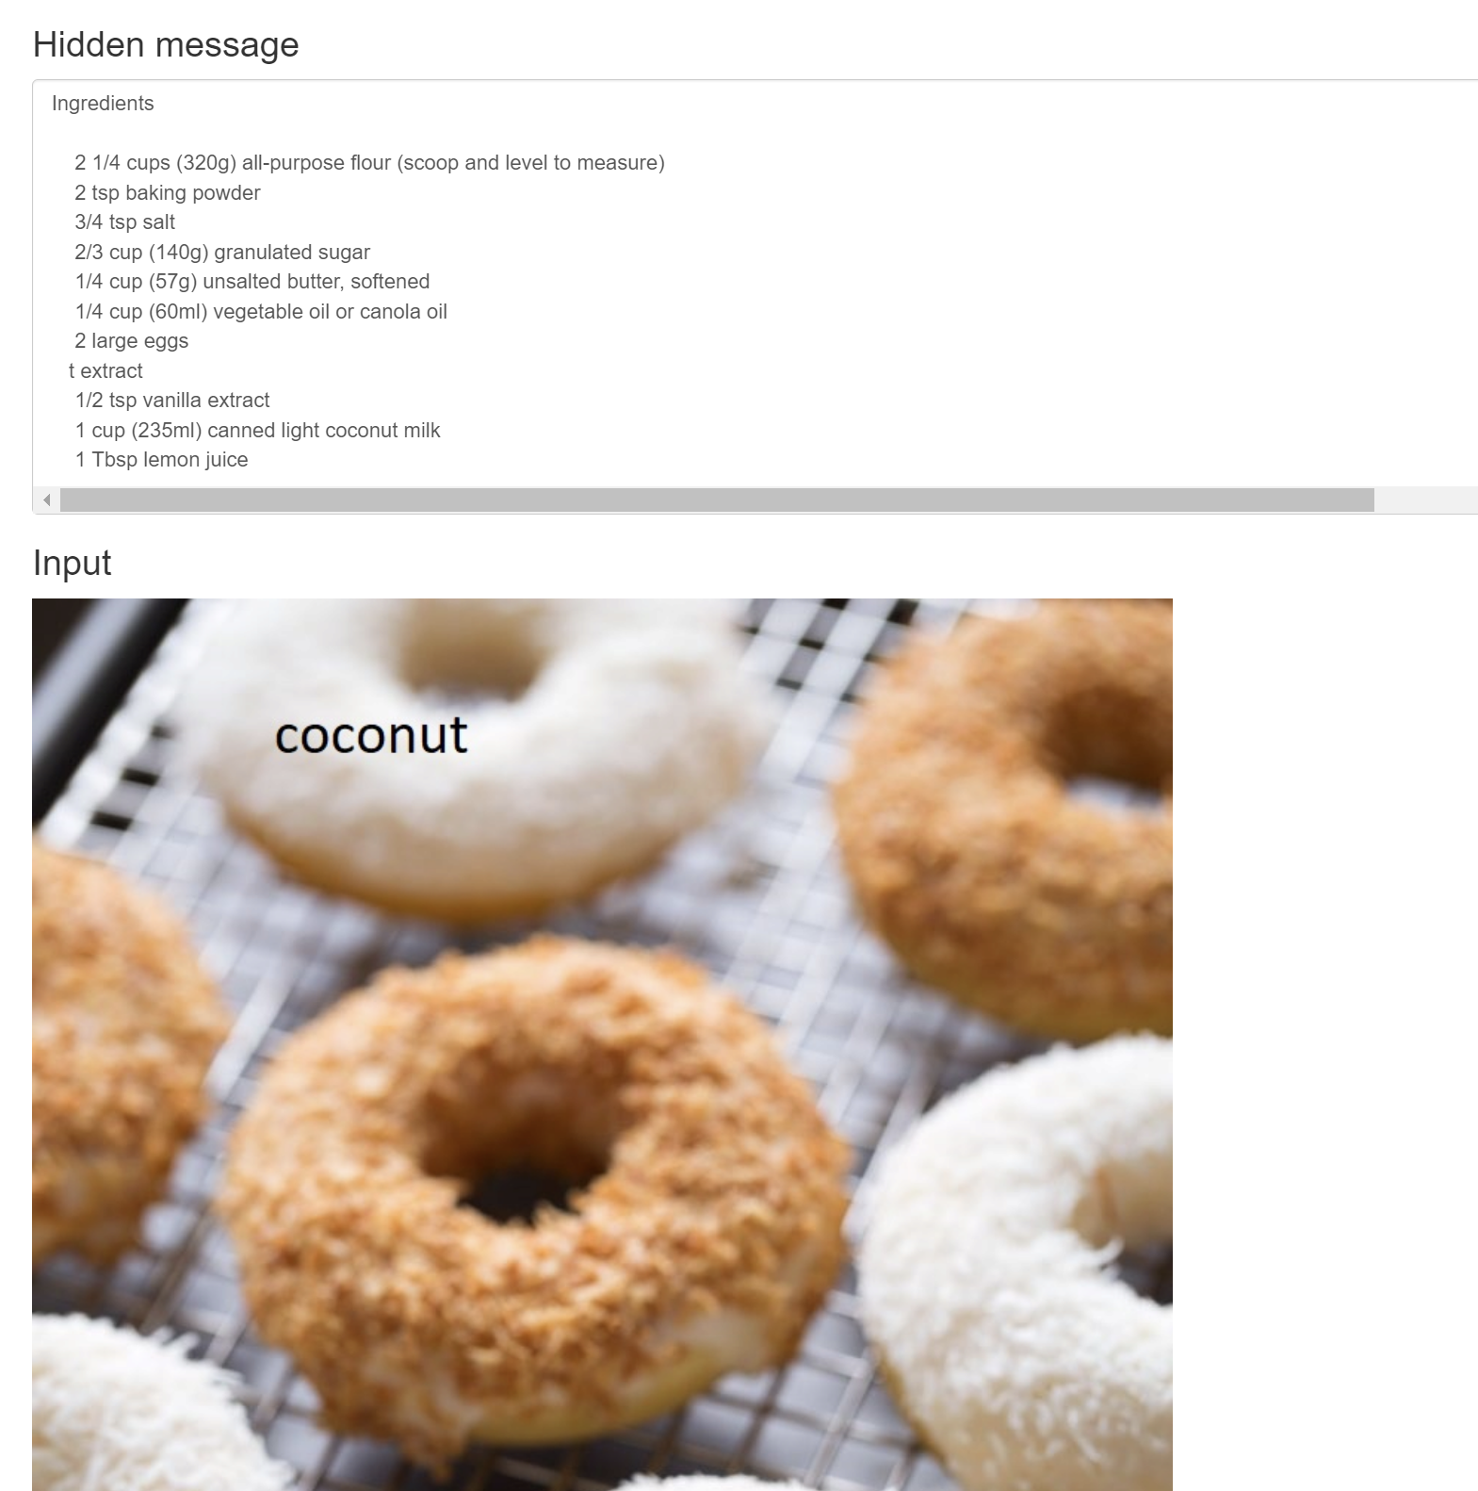

Figure : GIVES US SOME MORE INFORMATION IN ANOTHER IMAGE.

* From the file coconut.jpg we can get some more information on decoding the image in a steganography decoder.
* If we observe closely the recipes hidden here are the recipes corresponding to the images.
* But this isn’t the company’s main prized asset (recipe of honey duff doughnuts).
* While binwalking all the files we come across a file 1.png which is an image of a pink doughnut, and we find some interesting stuff on the binwalker in Kali Linux.



Figure : FILE 1.PNG

* This is the image 1.png that has another file embedded in it and can be found on binwalker.

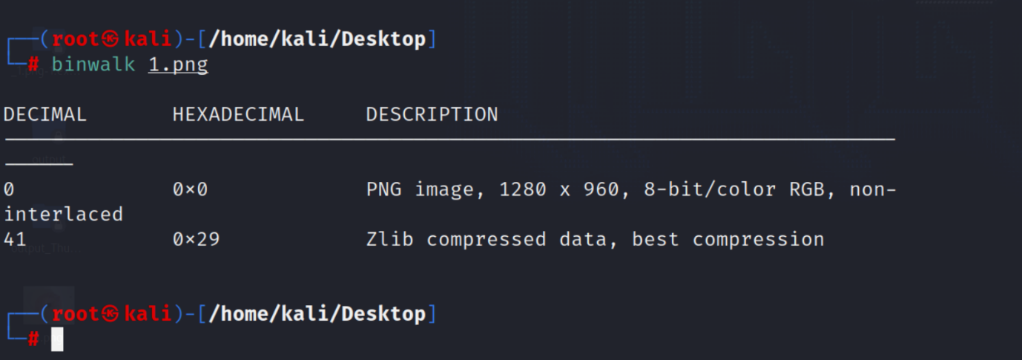

Figure : BINWALK RESULT FOR FILE 1.PNG

* Here in the binwalk result we can find another file embedded in one file.
* From the message that LISA sent to her dad the recipe is hidden in the pink doughnut and we, fortunately, find a file embedded in a file containing an image of a pink doughnut.
* Now, we try to extract the file and try to read its contents.
* For extracting and reading the contents of the file we use the tool STEGOSHARE.

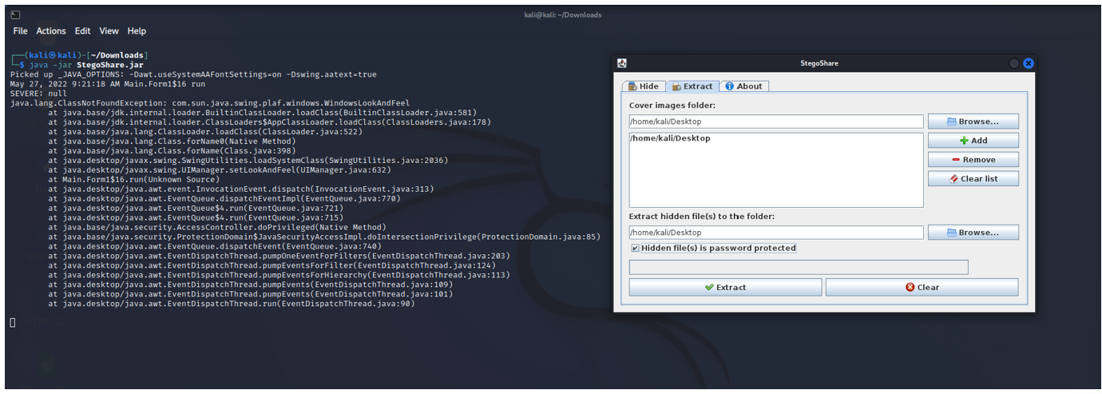

Figure : SHOWS US THE STEGOSHARE INTERFACE.

* But when trying to extract the contents of the file it was asking for a password. The password is found with the help of figure 2, in which LISA says that the secret lies in the pink donut.
* There are 2 different images of pink donuts in total one of them is 1.jpg and the other one is SpecialDonut.jpg

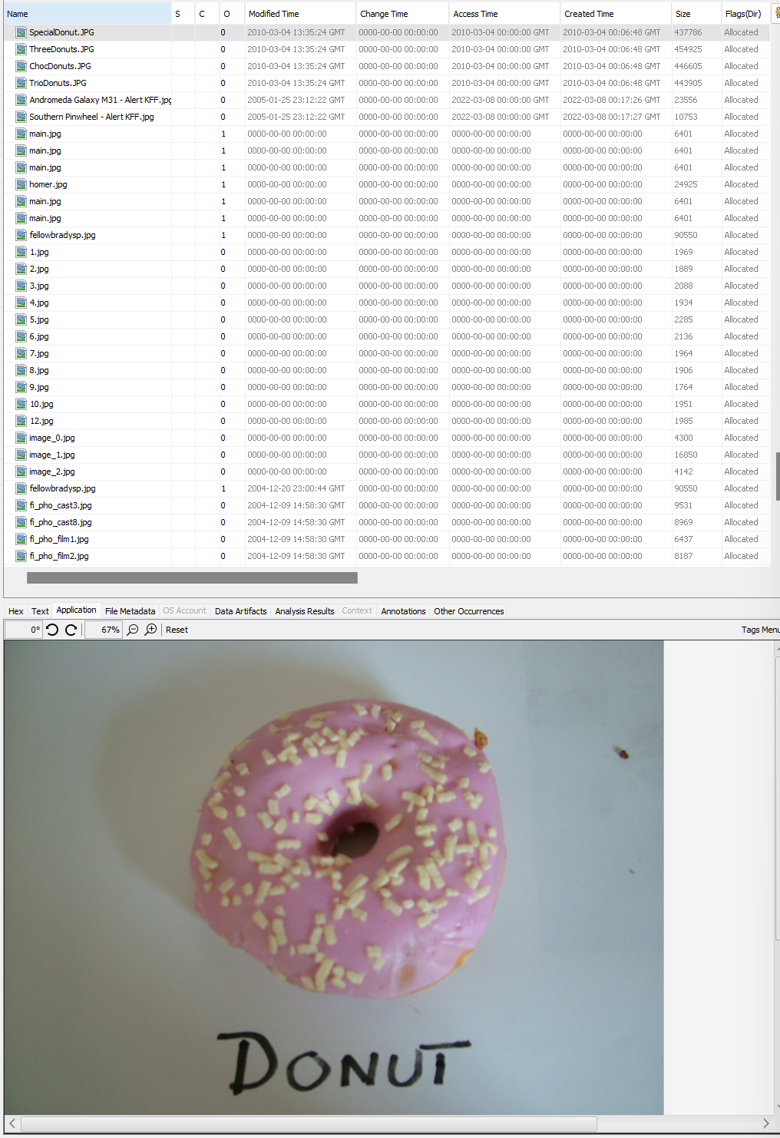

Figure : SHOWS US THE IMAGE OF THE PINK DONUT (SPECIALDONUT.JPG)

* For the extraction of 1.jpg we needed a password and we used DONUT ( from the figure 12) as the password.

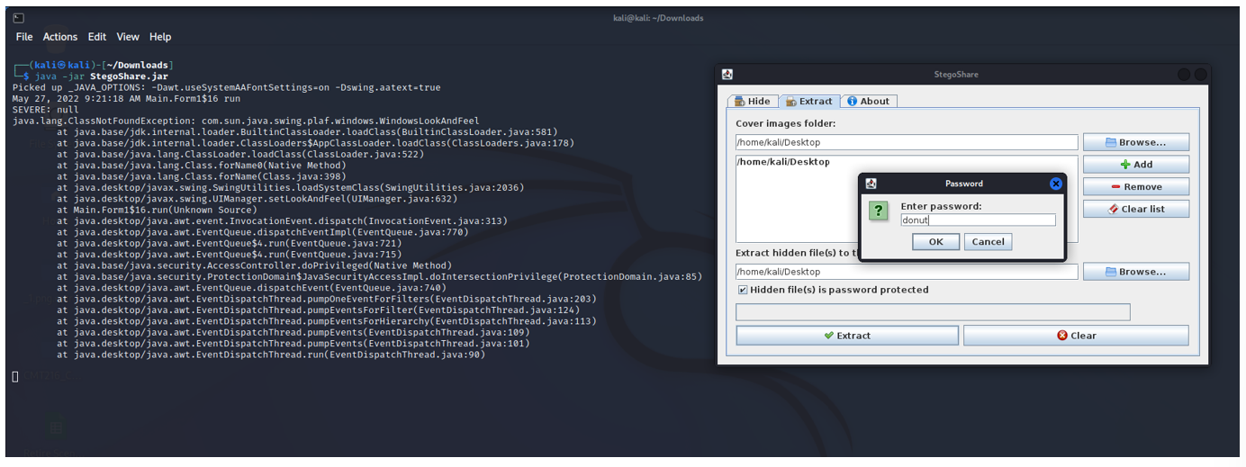

Figure : DONUT HAS BEEN GIVEN AS THE PASSWORD.

* After the password was given it was successfully extracted and showed us the contents of the file which was none other than the recipe of the honey duff donuts which the company was afraid of the leakage.

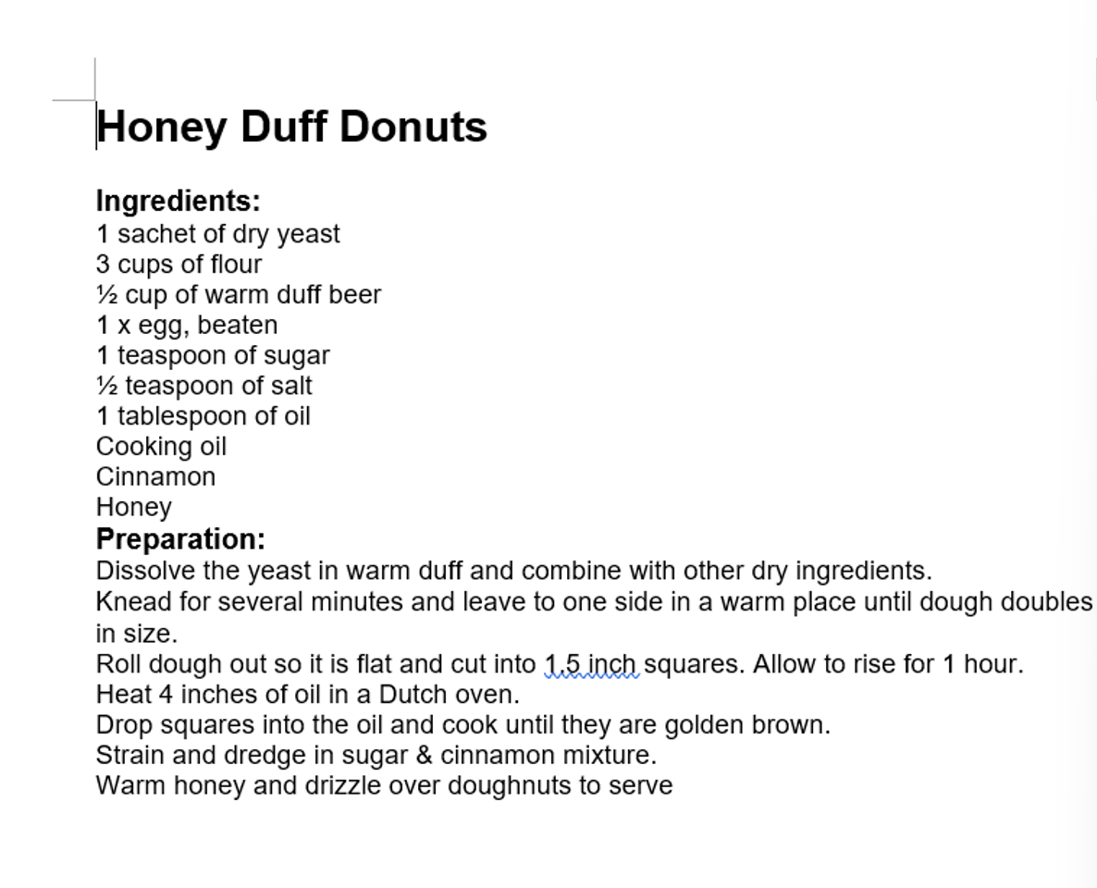

Figure : SECRET RECIPE OF HONEY DUFF DONUTS

* **STEPS TAKEN TO HIDE THE EVIDENCE:**
* Steganography encoding was used to hide information in an image which on decoding it on an online steganography decoder we find some valuable evidence.
* Another method used in hiding the evidence is by embedding a file in a file which can be seen by using binwalk in Kali Linux and when trying to extract it using stegoshare we can see that the file is password protected.
* After cracking the password (DONUT) by using the information available in one of the images we find the recipe for the honey duff doughnuts.

**CONDITION OF THE PHONE IN EXHIBIT – A:**

***FRONT:***

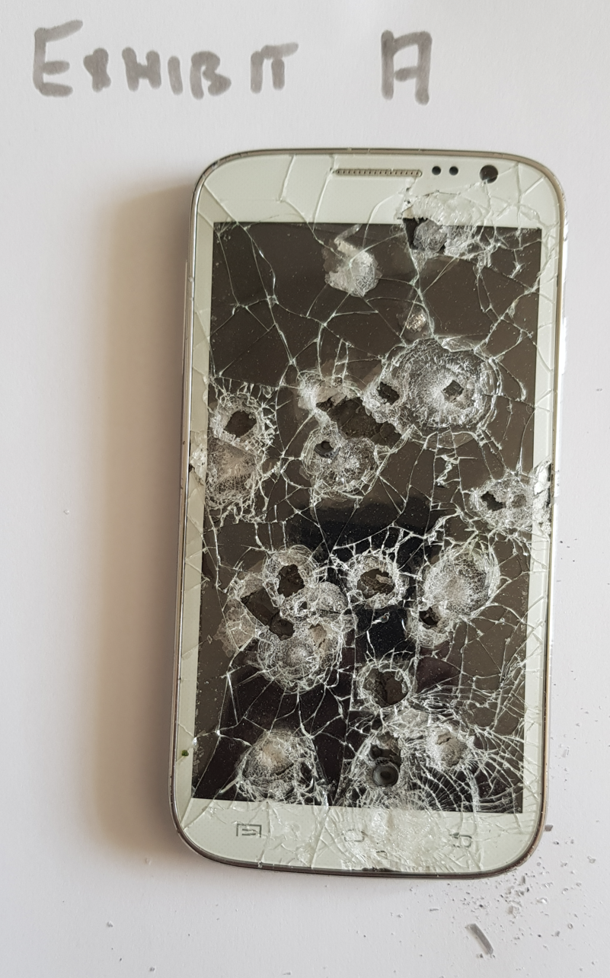

Figure : MOBILE PHONE FOUND DURING POLICE SEARCH.

Exhibit A (MOBILE PHONE) that is found during police search which when observed we can say that they’ve tried their level best to destroy it.

* The front part of the phone is almost completely shattered and on first look, it might look like bullet holes but if we take a closer look, we can say that it has been shattered using a weapon.
* Only the screen has been destroyed and there is some damage to the internal parts of the phone

***REAR:***

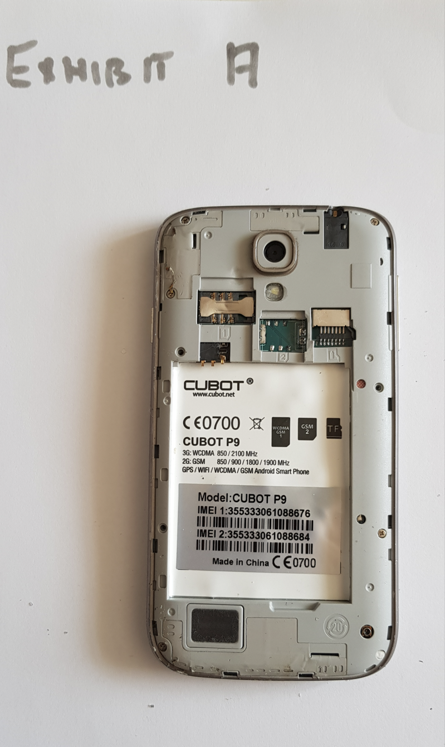

Figure : REAR PART OF THE PHONE FOUND DURING THE SEARCH.

* There is a lot of information on the rear side of the mobile phone.
* Manufacturer – CUBOT

Model - CUBOT P9

SIM1 – NOT AVAILABLE

SIM2 – NOT AVAILABLE

MEMORY CARD – NOT AVAILABLE

OPERATING SYSTEM – ANDROID

BATTERY – NOT AVAILABLE

**LIKELIHOOD OF OBTAINING EVIDENCE FROM THE PHONE:**

* On observation we can say that only the front part of the mobile phone has been tried to damage whereas the rear part is completely fine.
* To obtain and analyse data from the machine, the examiner may need to employ a variety of forensic tools. Because of the wide variety of mobile devices, there is no one-size-fits-all solution for mobile forensic tools. As a result, it is best to employ more than one tool for inspection. Popular forensic software solutions with analytic capabilities include Access Data, sleuth kit, and EnCase. Depending on the kind and model of mobile device, the best tool(s) are selected.
* As there is no external memory chip in place it is only possible to retrieve data from the phone.
* The first steps of any digital investigation involving a mobile device, the expert needs to identify:
* Type of the device – GPS, smartphone etc
* Type of network – GSM, CDMA or TDMA
* Service provider.

**OPTIONS AVAILABLE TO TRY AND EXTRACT DATA FROM A SHATTERED PHONE:**

Different types of data gathering can be performed by forensic analysts. The most basic method is called "manual acquisition," and it entails browsing through the phone normally. This does not expose erased data; hence it does not provide much information to analysts.

A "logical acquisition" offers more specific information. This entails transmitting data from the phone to a computer. This transfer makes it easier for forensic investigators to deal with the data, but it is still improbable that erased information can be recovered.

Investigators utilise a "file system acquisition" to view secret data. Mobile devices are large databases and acquiring a file system provides investigators access to all the files in the database. This includes hidden and root files; however, it does not contain deleted data.

Forensic analysts can collect several forms of information. The simplest way is known as "manual acquisition," and it comprises just looking through the phone. This is not an expose. There is also a "physical acquisition." This is the most difficult type of acquisition since it requires specific equipment to dump a copy of the storage into a file. However, this exposes everything, including deleted files. This enables techniques such as forensic text message retrieval.

The sorts of recoverable files may vary depending on the device being worked on by a forensic analyst. However, the following basic kinds are likely to be recovered:

* Text messages and iMessages
* Call history
* Emails
* Notes
* Contacts
* Images and videos.

WAYS TO HACK A DAMAGED PHONE:

* JTAG method
* CHIP OFF method.

JTAG is an abbreviation for the Joint Task Action Group, an industry group founded to provide a standard to produce Integrated Circuits. The forensic approach makes use of taps, which are short for test access ports and are often employed by manufacturers to test their circuit boards. Investigators can access the data from the chips by attaching wires to taps.

Delicate metal pins connect chips to the circuit board of a phone. An earlier version of the chip-off procedure entailed professionals delicately peeling the chips off a PCB, but this risked breaking the small pins, making data retrieval difficult. For the latest chip-off approach, forensic professionals scrape down the PCB to the pins beneath the chip before inserting it into a scanner.